|  |
| --- |
| LP.inc |
| DareToSlip |
| **3D-Game(First Person Perspective)** |
| Version #1.3  All work Copyright © 2016 by LP Games.  All rights reserved. |
| **Lovepreet Ralh** |
|  |



|  |
| --- |
| March 25th 2016 |

**Table of Contents**

Contents

Version History 3

Game Overview 4

Interface Sketch 4

Menu and Screen Descriptions 4

# Version History

<https://github.com/ralhpreet/DareToSlip3D>

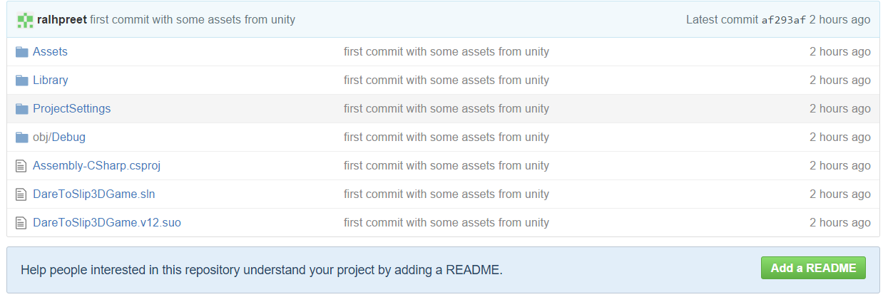

# Game Overview

DareToSlip is a 3D game in which a player have to walk over a 3D platform, and has to reach from one end to the other end going through some hurdles like fire and enemies. He can also collect some bonus(Energy Drinks)

# Interface Sketch

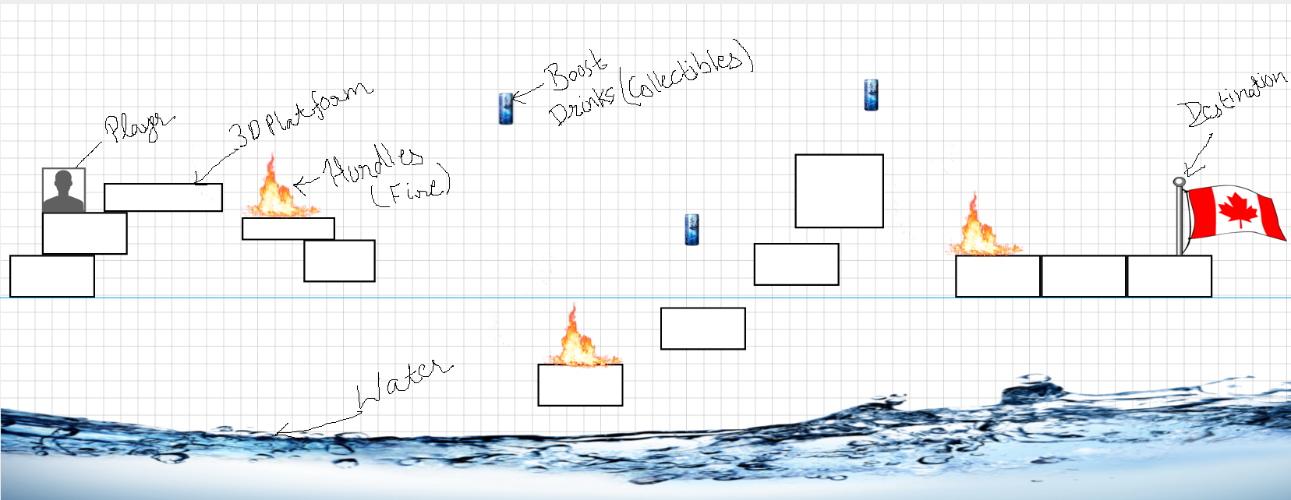

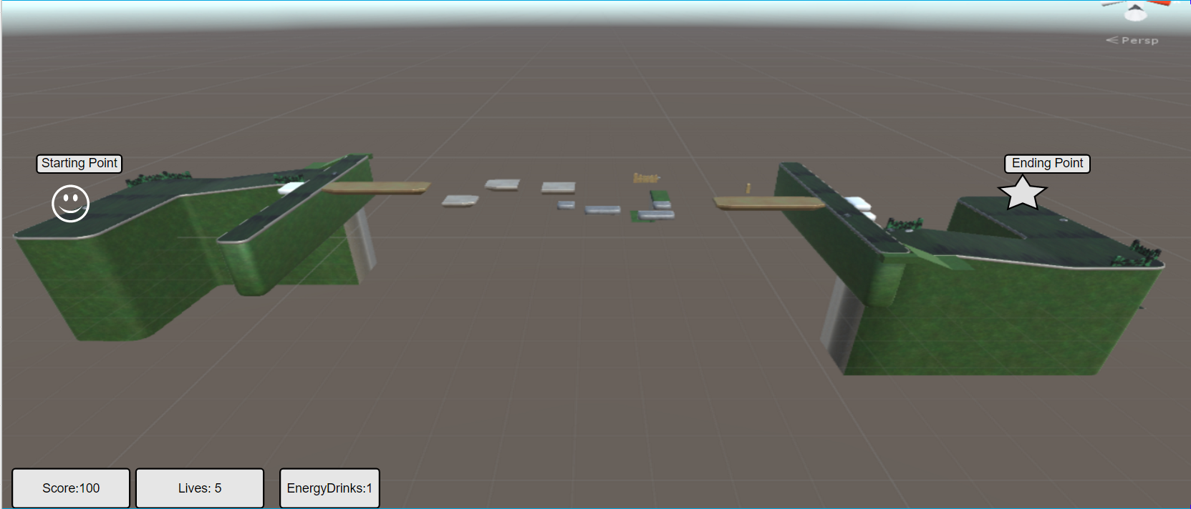

# Menu and Screen Descriptions

Play and Game-Over Screen.

Restart Menu button.

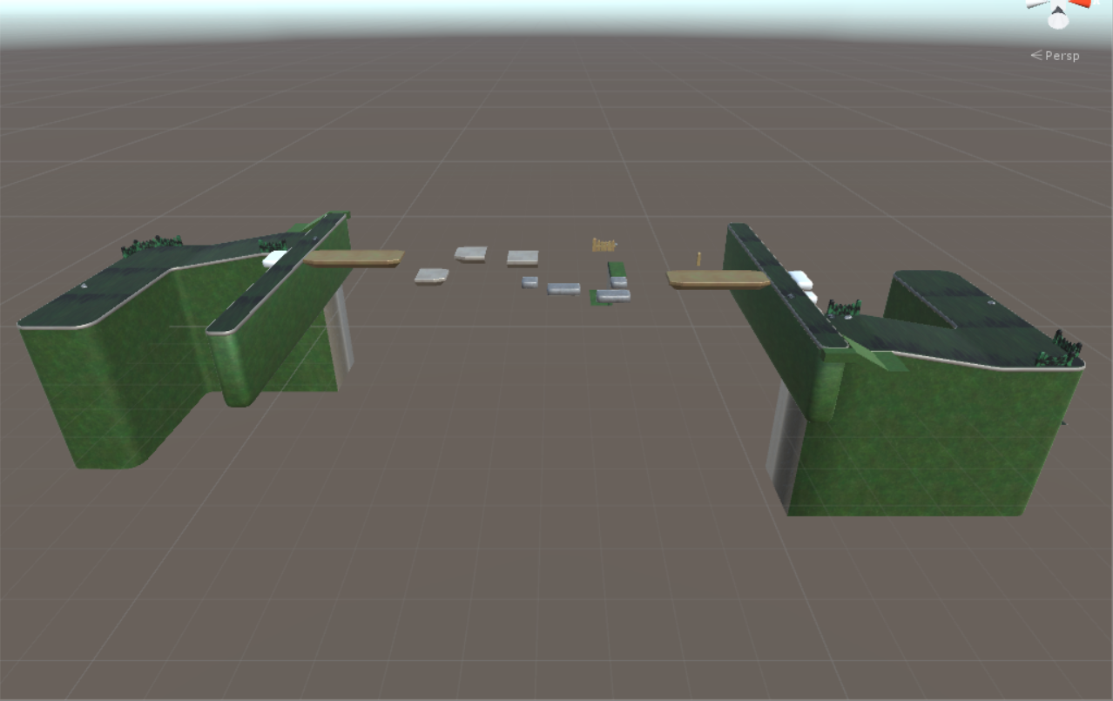

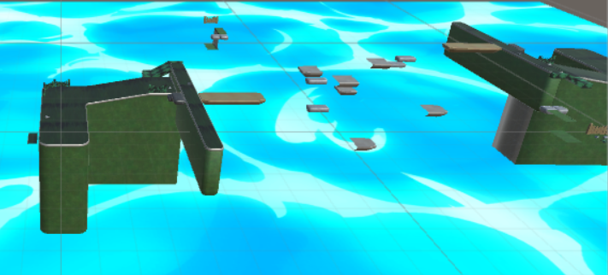

# Screen Descriptions

## Game Start with fire, energy drinks and a player

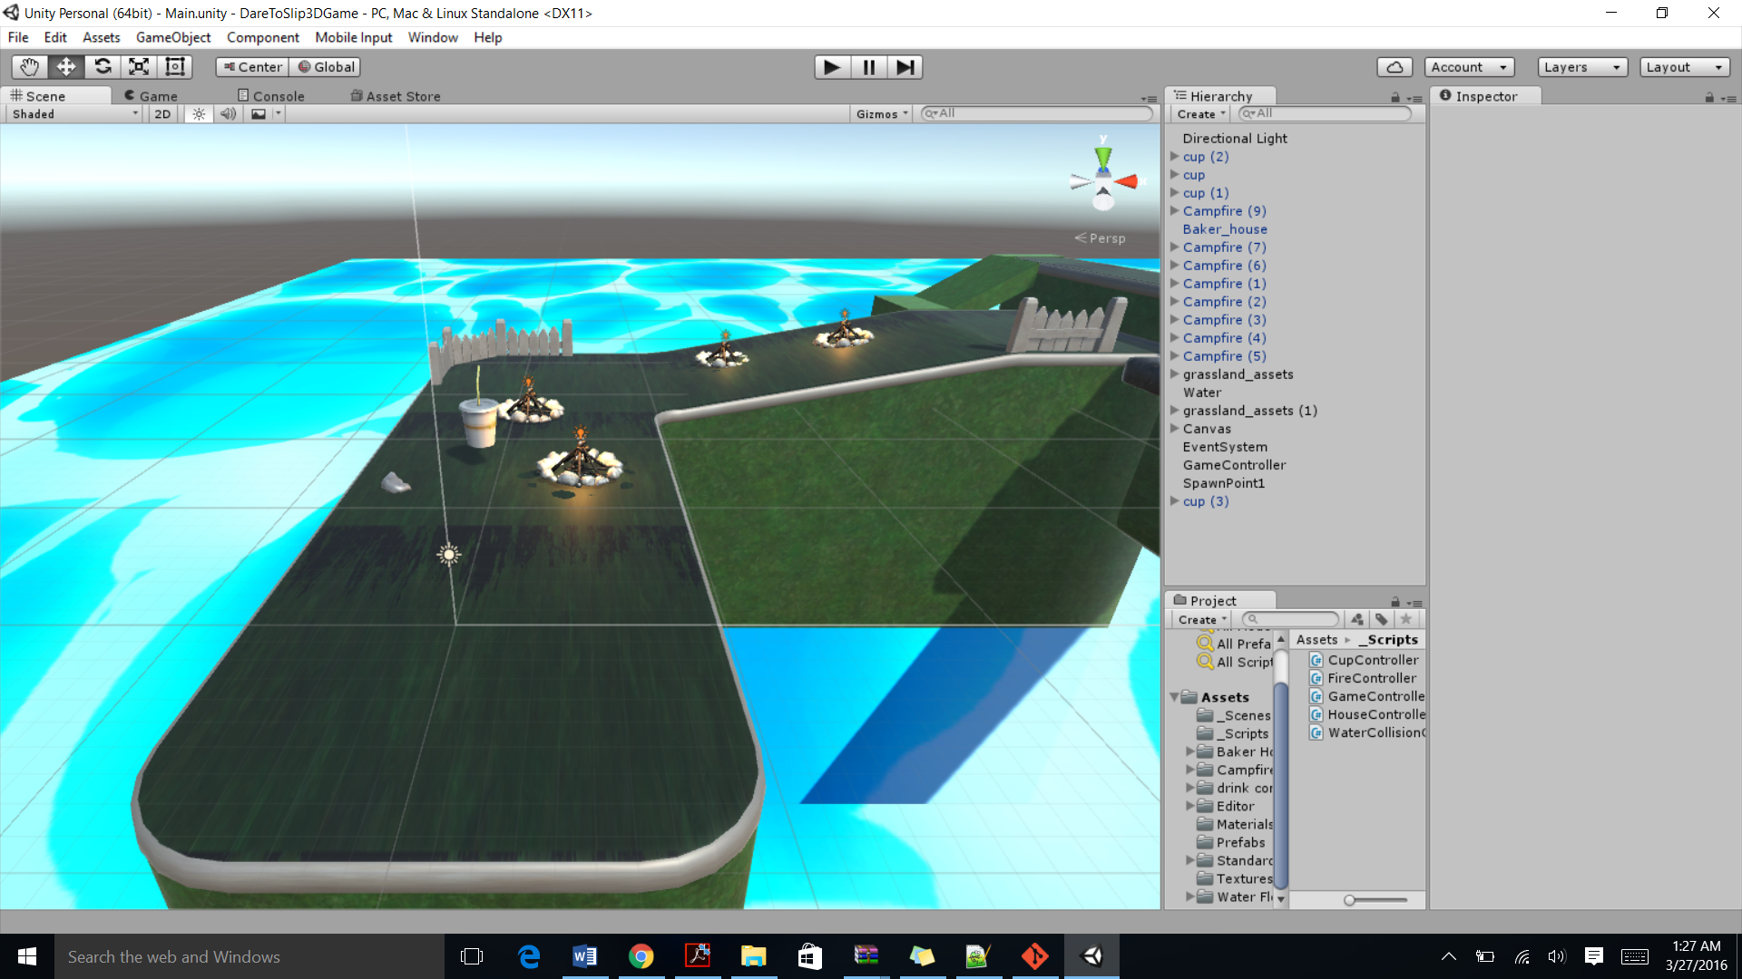

Screen with **fire** and **energy drink**.

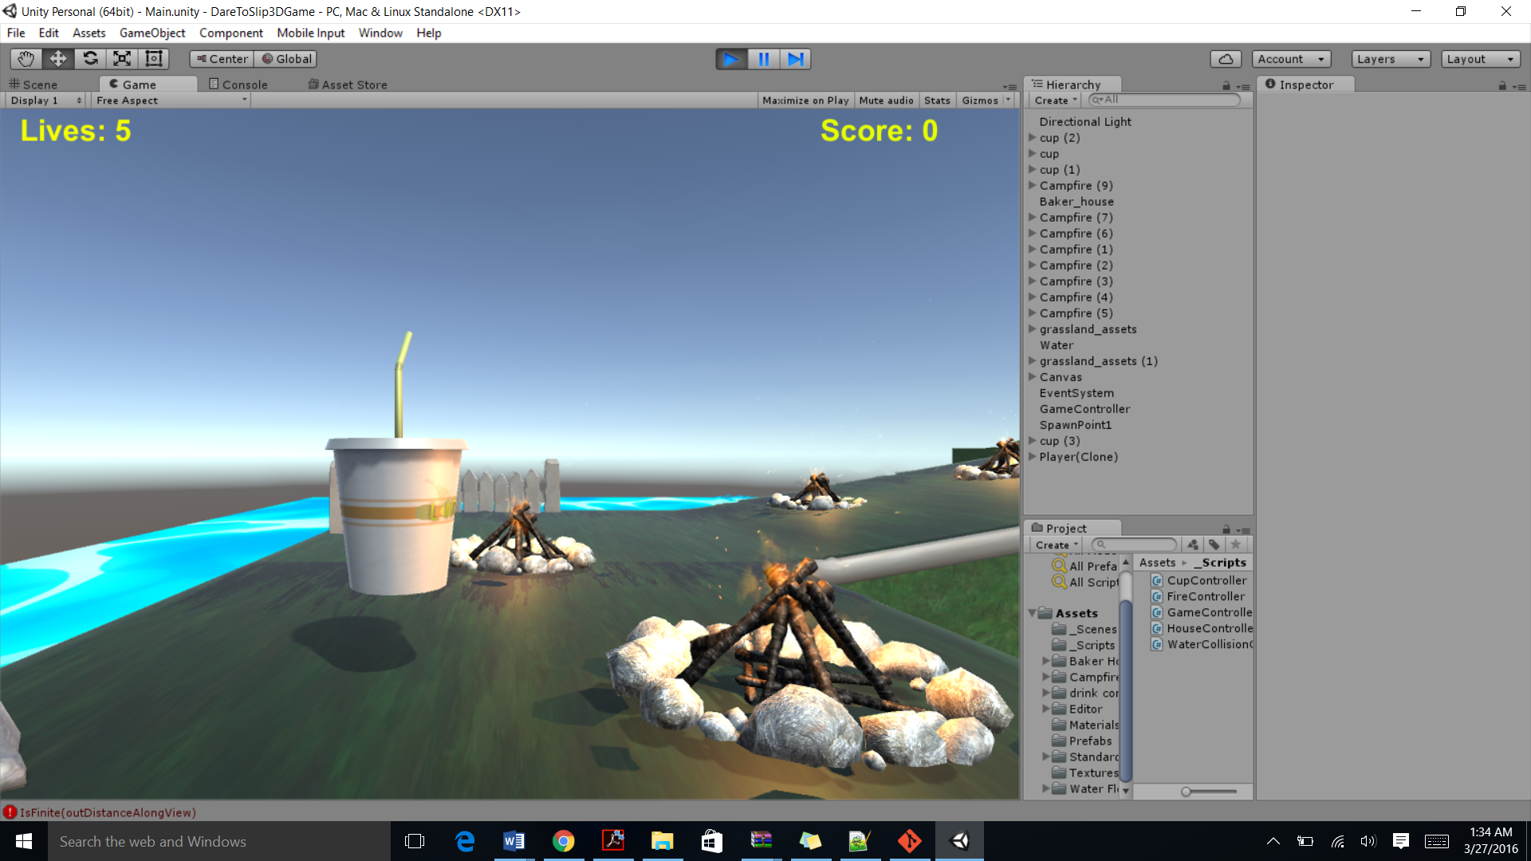

Game Over Screen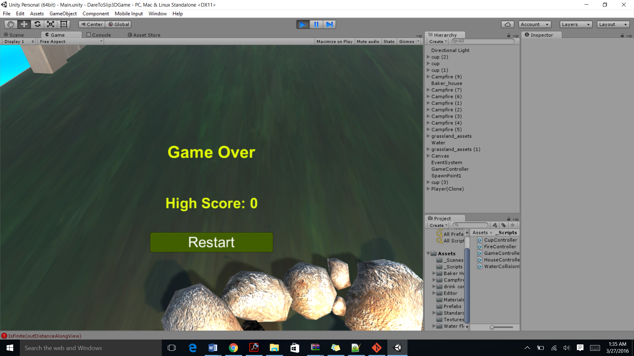

## Game Ending Point

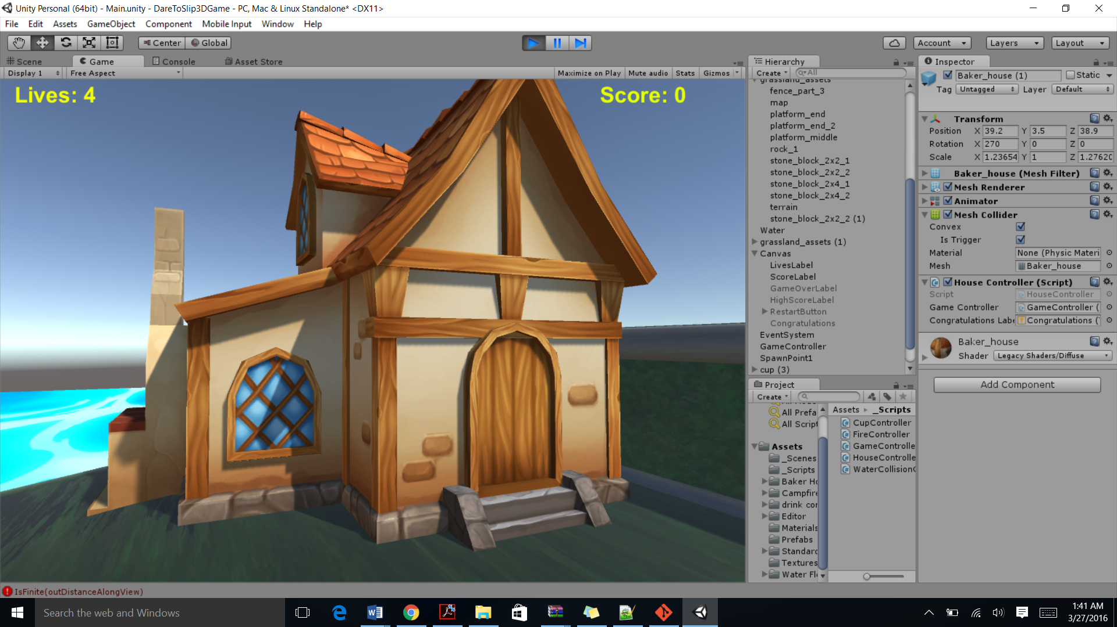

Game Level Completed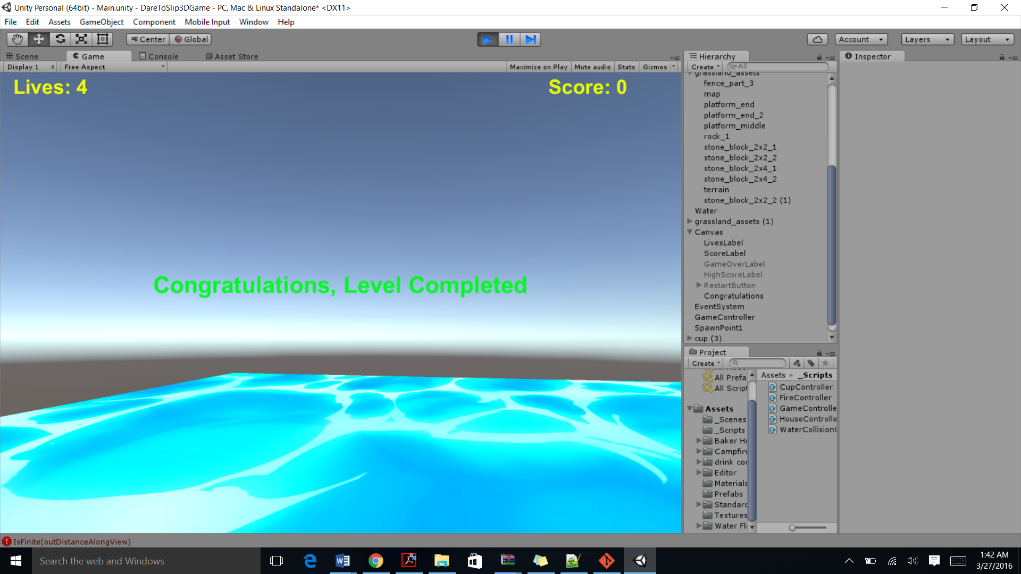

1. **Characters**

*The main character in this game is a first perspective player that can be controlled through the keyboard.*

1. **Enemies**

The enemy in this game is fire that acts as a hurdle and each fire collision reduces player’s life by one. The game is over once the life reaches zero.

1. **Scoring**

The player can score points by collecting energy drinks and each drink collected by the player rewards him with 100 points.

1. **Sound Index:**

Default player steps, jump and land sound.

1. **Art / Multimedia Index**

**Player: Downloaded from Unity Asset Store.**

**Fire: Downloaded from Unity asset store.**

**Cups (Energy drinks): Downloaded from** [**http://opengameart.org/content/drink-cup**](http://opengameart.org/content/drink-cup)

**House: Downloaded from Unity Asset store**

**Platform Assets: Downloaded from** [**http://opengameart.org/content/basic-3d-platformer-pack**](http://opengameart.org/content/basic-3d-platformer-pack)